Veasey Memorial Park / Nest Box Summary Report – 2025

OVERVIEW
There are 7 nest boxes scattered across the field in Veasey Memorial Park (VMP) that provide nesting sites for eastern bluebirds (EABL) and tree swallows (TRES). Six of these nest boxes have been placed close together in pairs, while there is a single nest box near the bottom of the driveway close to the canoe launch. Though not an obligate cavity nester, the house sparrow (HOSP) will readily accept a nest box that is located near buildings and other structures. In the past, house wrens (HOWR) have occasionally used nest boxes that are near the woodland edges of the field.
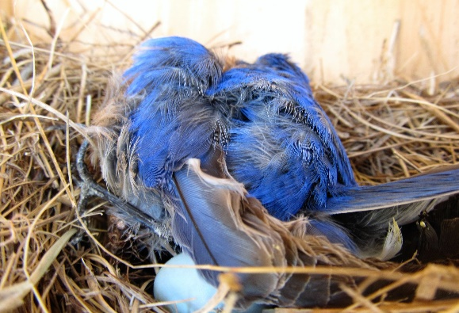
Unfortunately, house sparrows present challenges by taking nest boxes that would otherwise be available for bluebirds and swallows, which nest only in natural cavities or nest boxes. This sparrow is an invasive species and presents a threat to nesting bluebirds and swallows. It is not unusual for a male sparrow to enter a nest box, and destroy any eggs and eject nestlings from the box. If the sparrow encounters an adult, it will often peck the head of its victim resulting in fatal head trauma as seen in Photo 1. What makes this incident even more distressing is the presence of an unhatched bluebird egg next to the dead adult. This nest was subsequently abandoned by the female. For this reason, any nest attempt by a house sparrow is discouraged.
Photo 1. Dead Male Eastern Bluebird with Head Trauma Inflected by a Male House Sparrow in a Nest Box in Ward Reservation (Andover MA).
NESTING IDENTIFICATION AND BREEDING ACTIVITY
It is relatively easy to identify what avian species is using a nest box. The construction of the nest and the size and color of the eggs will make identification easy. In the case of a tree swallow, its egg is approximately the same size as bluebird egg but entirely white. In contrast, a bluebird egg is a robin’s egg blue with no markings. The egg-size of each species is approximately 0.8 inches in length. The typical clutch size ranges from 3-5 eggs and 4-6 eggs for the bluebirds and the swallow, respectively. Both species build similar cup-shaped nests using dry vegetation that is found in the field or nearby woodlands. The tree swallow characteristically builds a nest with dry grass and line the nest with white feathers, while the bluebird constructs a nest with pine needles without feathers, thus, differentiating between their nests is simple. In sharp contrast, a house sparrow builds a rather messy-oversized and whirled-shaped nest made of grasses and almost anything else the female can find, including paper, cigarette butts, cellophane wrappers, and other pieces of trash. In appearance, a sparrow egg is light in color with brown mottling and similar in size to bluebird and swallow eggs.
As the house sparrow is an invasive species and a general nuisance and threat to bluebirds and swallows, a concerted effort is made to discourage it from nesting. To discourage predatory behavior by house sparrows, invasive species management was consistently practiced by removing sparrow nests and eggs. In many instances when a nest is removed, the female sparrow will attempt another nest in the same box soon after her nest was removed. There were two unsuccessful nest attempts by sparrows this season. The house sparrow is a nonnative and invasive species, so it is not protected by the Migratory Bird Treaty Act.
Eastern bluebirds typically will not nest within at least 300 feet of another pair of bluebirds, which is the reason it is unlikely to have more than 2 pairs of bluebird nesting simultaneously in the Veasey field. Conversely, tree swallows are more social and less restrictive regarding nesting separation and breeding territory. Surprisingly, the eastern bluebird and tree swallow show little hesitancy to nest next to each other. One reason for this disparity is that they exploit different foraging stratums. Bluebirds prefer foraging near or on the ground often swooping from a perch to seize prey, a strategy referred to as “hawking.” In contrast, swallows are aerial insectivores that forage by gathering prey in flight often well above the ground. Both avian species feed predominantly on insects and other small invertebrates. Interestingly, the tree swallow is the only swallow breeding in North America that includes berries in its diet. Due to their mixed diet, tree swallows return earlier and migrate later from their breeding grounds than any other swallow in North America. Bluebirds also supplement their diet with berries especially during winter but do not migrate.
This communal nesting phenomenon can be taken advantage of by pairing nest boxes. As nesting bluebirds will not nest close to another pair of bluebirds, distances between paired boxes should be separated by at least 300 feet. With the expense and effort needed to install nest boxes, this arrangement is an efficient nest box configuration. This practice can be seen in the Veasey field where six (6) of the seven boxes are arranged in pairs. The paired boxes are as follows: 12VP/12AVP (near the driveway), 10VP/11VP (near the oak tree) and 16VP/16AVP (at the top of the hill near the woodland edge). There is single nest box, 1VP, located along the driveway near the canoe launch.
Due to its larger size, the bluebird has a distinct competitive advantage over the swallow when acquiring a nest box. As bluebirds typically begin nesting before swallows, a bluebird pair will have selected one of the paired boxes, leaving the other box available for swallows. The bluebird pair will offer little or no aggression when their neighbor is a pair of swallows but will fiercely defend their breeding habitat against another pair of bluebirds. Bluebirds often have a second brood in the same nest box or the adjacent box. Being single-brooded, nesting swallows will only use a nest box once during a breeding season. Swallows are also great sentinels around their nests, and will dive at anything they perceive as a threat. Since swallows do not perceive bluebirds as threats, this behavior also benefits bluebirds nesting in the adjacent nestbox.
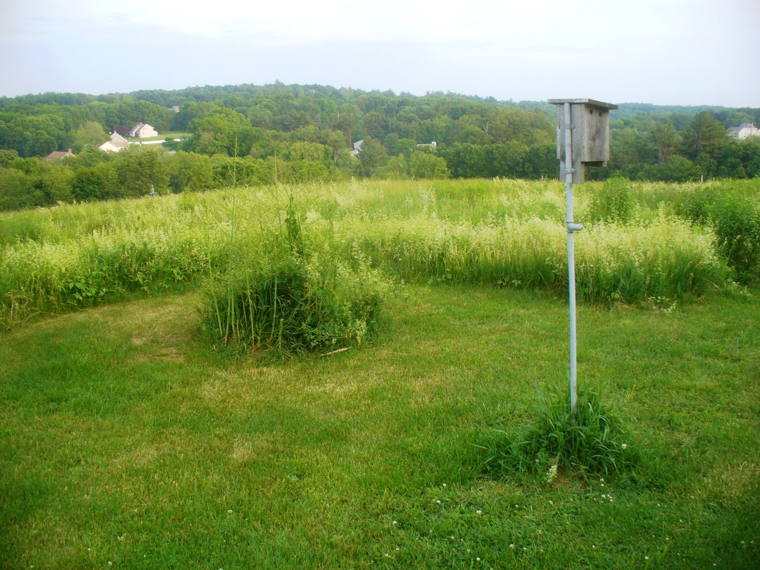
The bobolink (BOBO) is another species that nest in fields and grasslands, preferring an herbaceous vegetative cover greater than a foot in height. The bobolink is a little larger than an eastern bluebird. The male, which is solid-black below and displays large white patches above with a significant olive-colored patch on the nape of its neck, is by far more striking than the female. The female, which displays buff coloring with extensive striping across the head and back, builds a nest of grasses and other herbaceous vegetation directly on the ground. Locating a nest is rather difficult as the bobolink immerges or disappears into the vegetation some distance from the nest. Though, male bobolinks were present in the field early in the season, I did not observe activity later in the breeding season. The field has become shrubbier, making it less appealing to bobolinks for nesting. Though, there were several bobolink observations in eBird from May 4th until June 29th.
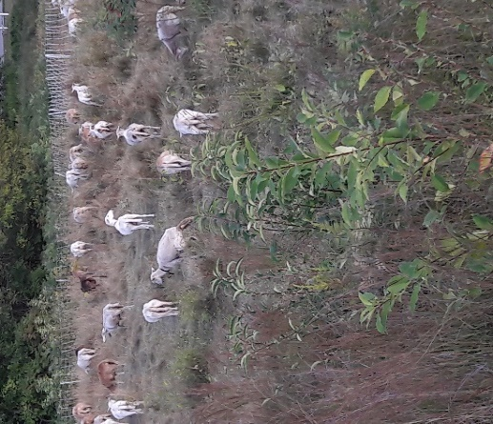
The Groveland Highway Department continues to regularly mow and maintain the interconnected Veasey field trails. These trails provide easier access to the nest boxes, making maintenance and nest monitoring more convenient. These trails also allow park visitors the opportunity to wander through the field, which is especially pleasant late in the season when vegetation is high. The trails also offer better viewing of nest boxes and wildlife activity, particularly, butterflies, dragonflies, and other field-loving invertebrates, in addition to the grassland birds. Since 2005 delayed mowing of the field has been practiced, which helps to attract ground-nesting birds like bobolinks and savannah sparrows, as well as a bounty of butterflies and dragonflies and other invertebrates that birds and their young thrive on. As bobolink young do not fledge until mid-summer, delayed mowing is critical for the survival of the fledglings. For the past several years, goats and sheep have been retained to manicure the Veasey field as shown in Photo 3.
Photo 2. Nest Box in the Field of Veasey Memorial Park Field
Photo 3. Goats Grazing in the Veasey Field
NEST BOX MONITORING
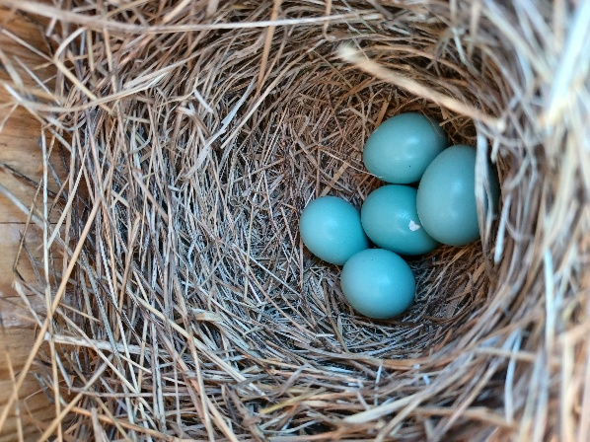
In the Northeast, bluebirds often attempt their first nest early in April, while tree swallows tend to wait until later in the month or even May, and usually have completed their nesting by July. Since both April and May can present cold and wet weather, and limited food opportunities, successful nest attempts can be quite challenging for bluebirds. Though the tree swallow is single brooded (a single nest per season), the eastern bluebird might have 2 or 3 broods during a season. In 2025 the first-egg-date (FED) for the bluebird in the Veasey field was April 9th, while the FED for the tree swallow was May 27th. There were 2 nest attempts by house sparrows both occurring in nest box 11VP. Invasive species management was used to prevent successful nest attempts.
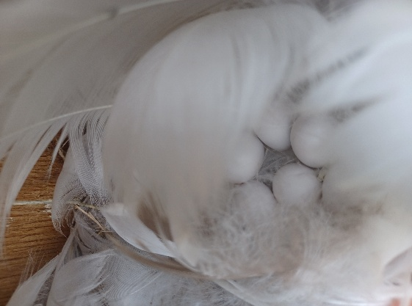
Photo 4 shows the first clutch of bluebird eggs of the season in nest box 1VP, while Photo 5 presents the first clutch of tree swallow eggs in nest box 12AVP. Notice how the female swallow conceals her eggs with white feathers. Unfortunately, these eggs disappeared from an apparently undisturbed nest except for a scattering of white feathers on the ground under the nest box. The fact the nest showed little disturbance points toward snake predation as the likely cause of their disappearance (refer to Appendix B).
Photo 4. First Clutch of Eastern Bluebird Eggs of the 2025 Season in Nest Box 1VP.
Photos 6 and 7 reveal how quick bluebird development occurs. In Photo 6 we see 4 recently hatched bluebirds, naked and helpless, then just 12 days later Photo 7 presents these same bluebirds fully feathered with eyes wide open.
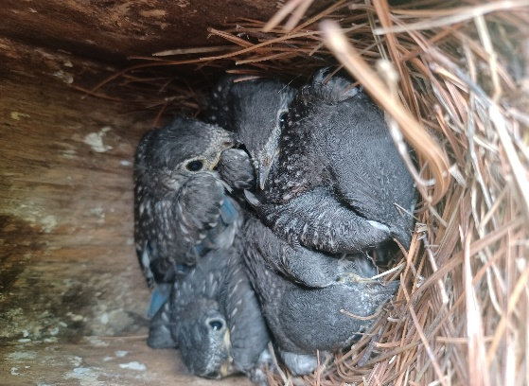
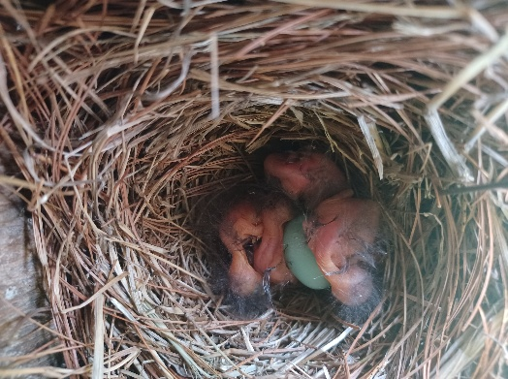
During this season there were 4 bluebird nest attempts of which 3 were successful, producing 19 eggs and 12 fledglings, with an average productivity of 3.0 fledglings per nest attempt. Unfortunately, the first clutch of the season in nest box 1VP, all 5 nestlings succumbed most likely due to the unusually cold and wet weather in mid-May. Tree swallows had 2 nest attempts, one of which was unsuccessful, producing a total of 11 eggs and 5 fledglings, with a productivity of 2.5 fledglings per nest attempt. The failed nest attempt was most likely due to snake predation. Overall, bluebirds fared better than tree swallows with an average nest productivity of 75%, while swallow’s nest productivity was 50%.
Photo 5. First Clutch of Tree Swallow Eggs of the 2025 Season in Nest 12AVP.
Table 1 highlights nest box data that includes the total number of nest attempts and the number of successful attempts (producing at least one fledgling) as well as the total number of eggs, hatchlings, and fledglings. Table 2 presents additional nest box data, including the average number of eggs, nestlings, and fledglings per nest attempt. During the 2025 nesting season, the average number of eggs per nest attempt for bluebirds and swallows were 4.75 and 5.5, respectively, and within the expected ranges of 3-6 and 4-7 eggs per nest attempt.
Photo 6. Hatching Eastern Bluebirds in Nest 12VP - June 4, 2025
Photo 7. Fully feathered Eastern Bluebirds in Nest Box 12VP – June 16, 2025
Since 2008 nest box data has been shared with the NestWatch Program of the Cornell Lab of Ornithology (CLO). By sharing our nest box data with NestWatch, the data can then be downloaded as Excel spreadsheet files, which are helpful for reviewing and organizing data.
Table 1. Nest Box Data for 2020- 2025 at Veasey Memorial Park
Season | Species | Total # Nest Attempts | First-Egg –Date of season | Total # of Eggs | Total # of Hatchling | Total # of Fledgling | Nest Attempts w/ 1 or more Fledglings
2020 | EABL | 4 | 05/16/2020 | 15 | 15 | 10 | 3
2020 | TRES | 5 | 06/24/2020 | 27 | 27 | 26 | 5
2021 | EABL | 5 | 04/10/2021 | 22 | 21 | 13 | 4
2021 | TRES | 4 | 05/15/2021 | 21 | 19 | 8 | 2
2022 | EABL | 5 | 04/11/2022 | 24 | 20 | 20 | 4
2022 | TRES | 3 | 05/07/2022 | 12 | 12 | 12 | 2
2023 | EABL | 7 | 04/11/2023 | 30 | 22 | 17 | 5
2023 | TRES | 4 | 05/10/2023 | 20 | 20 | 20 | 4
2024 | EABL | 4 | 04/18/2024 | 20 | 20 | 20 | 4
2024 | TRES | 4 | 05/07/2024 | 20 | 20 | 18 | 4
2025 | EABL | 4 | 04/07/25 | 19 | 17 | 12 | 3
2025 | TRES | 2 | 05/27/2025 | 11 | 5 | 5 | 1

Table 2. Additional Nest Box Reproductive Data from 2020–2025 at VMP
Season | Species | Average # eggs per Nest Attempt | Average #Hatchlings per Nest Attempt | Average #Fledglings  per Nest Attempt
2020 | EABL | 3.8 | 3.8 | 2.5
2020 | TRES | 5.4 | 5.4 | 5.2
2021 | EABL | 4.4 | 4.2 | 2.6
2021 | TRES | 5.0 | 5.0 | 5.0
2022 | EABL | 4.8 | 4.0 | 4.0
2022 | TRES | 4.0 | 4.0 | 4.0
2023 | EABL | 4.3 | 3.1 | 2.4
2023 | TRES | 5.0 | 5.0 | 5.0
2024 | EABL | 5.0 | 5.0 | 4.5
2024 | TRES | 5.0 | 5.0 | 5.0
2025 | EABL | 4.75 | 4.25 | 3.0
2025 | TRES | 5.5 | 2.5 | 2.5
The NestWatch Protocol for Monitoring Nests (Appendix A) was used as a guide for nest box monitoring. And another great source of information is A Trouble-Shooting Guide for Nest Box Landlords found in Appendix B. This guide is valuable for determining the cause of nest predation. For instance, under the first column of this guide (what you might find) you will notice in the third block down, nestlings found dead in box with signs of trauma. Moving across to column 2 (3rd block down), you will discover that the possible cause of this event could be due to House Sparrow predation. In the third column, the guide suggests moving the nest box away from the area inhabited by House Sparrows.
RECOMMENDATIONS
- Following each nest attempt, the nest must be removed and from the nest box, and the box must be scraped out to remove any debris.
- Nest attempts made by House Sparrows in nest boxes must be deterred. Any sparrow nest with eggs must be removed from the nest box.
- Predator guards on 16VP and 16AVP will need to be repaired.
- To minimize contact with ticks during nest box monitoring, mowing of field trails should be extended to include nest boxes.
- Nest box inspection and maintenance prior to the breeding season is necessary to ensure old nest material has been removed and the boxes are clean and as weather tight as possible. Caulking cracks and spaces that have developed due to weathering and aging will help minimize weather-related nestling fatalities.
- The nest box monitoring effort will need another nest box monitoring volunteer to continue the nest box program in 2026.
SUMMARY
Early last century bird watchers noticed that the numbers of their beloved bluebird were declining. Conservationists noted that bluebird habitat was disappearing and the number of natural nest cavities becoming ever scarcer. The bluebird was also now competing for nest cavities with the house sparrow and European starling that had been introduced from Europe. Bluebird conservationists like Lawrence Zeleny, implemented conservation measures to reverse this trend. Throughout the eastern part of the country, concerned conservationists and bluebird enthusiasts began erecting nest boxes specifically designed to attract bluebirds, and coincidently attracted tree swallows. A series of strategically placed nest boxes became known as a bluebird trail.
As revealed in The State of the Birds published by the MAS in 2013, the Eastern Bluebird has successfully rebounded. According to the USGS Breeding Bird Survey (BBS), the eastern bluebird population trend in Massachusetts has been increasing by 4.79% per year from 1993 through 2022. The BBS population trend for the tree swallow is not so optimistic, and the tree swallow has been declining by -1.34% per year during this time interval. Many other field birds are experiencing an equally bleak outlook, such as the American kestrel, bobolink, and several field sparrows.
During the 2025 season, tree swallows made 2 nest attempts in nest boxes in the Veasey field producing a total of 11 eggs and 5 fledglings with a productivity of only 2.5 fledglings per nest attempt. In contrast, the bluebirds had 4 nest attempts producing 19 eggs and 12 fledglings with a productivity of 3.0 fledglings per nest attempt. Extreme weather and snake predation were reasons for lower productivity of these species. Though, male bobolinks were present in the field early in the season, I did not observe activity later in the breeding season. The field has become shrubbier, making it less appealing to bobolinks for nesting. Though, there were several bobolink observations in eBird from May 4th until June 29th.
Graph 1 presents the number of bluebirds and swallows that fledged from nest boxes in the Veasey field from 2020 through 2025. This graph reveals that the 2025 season produced the fewest number of tree swallow fledglings than any of the other years, and the number of bluebirds that fledged was well below the average for this time interval. Without a doubt, extreme weather like the stretch of wet and cold weather experienced in mid-May, which caused all the bluebird nestlings to perish in nest box 12VP, will continue to pose a threat in the future with more frequent heat waves, extended droughts, and heavy precipitation events as well as unusually cold temperatures in the spring that will challenge every nest attempt.

RESOURCE INFORMATION
- Cornell Lab of Ornithology Program.
http://watch.birds.cornell.edu/nest/home/index
Bird Guide … http://www.allaboutbirds.org/guide/search
NestWatch … http://nestwatch.org/
NestWatch Digest 2015 … http://nestwatch.org/connect/news/our-year-end-report-is-here/
- Salias … http://www.sialis.org/index.html
- How to Create and Manage Tree Swallow Nest Boxes http://www.treeswallowprojects.com/index.html
- Ehrlich P.R., Dobkin D.S., Wheye D. 1988. The Birder’s Handbook – a Field Guide to the natural History of North American Birds. Fireside Book Published by Simon & Schuster Inc.
- Massachusetts Bluebird Association … http://www.massbluebird.org/
- Mass Audubon Society, 2013. The State of the Bird. http://www.massaudubon.org/our-conservation-work/wildlife-research-conservation/statewide-bird-monitoring/state-of-the-birds
- Mass Audubon Society. Birds to Watch Program, American Kestrel. http://www.massaudubon.org/Birds_and_Birding/birdstowatch/kestrels/howyoucanhelp.php
- New England Nature Bluebird Information … http://www.nenature.com/EasternBluebird.htm
- North America Bluebird Society … http://www.nabluebirdsociety.org/
  - Bluebird Nest Box Plan … http://www.nabluebirdsociety.org/PDF/NABS%202020%20Eastern%20-Bluebird%20Nestbox%20Plans.pdf
- Peterson R.T., 1980 4th Edition. Eastern Birds, Peterson Field Guides. Houghton Mifflin Company, Boston
- Sibley D.A. 2003 First Edition. The Sibley Field Guide to Birds of Eastern North America. Alfred A. Knopf, New York.
- Sibley D.A. 2009. The Sibley Guide to Bird life & Behavior / illustrated by David Allen Sibley; edited by Chris Elphick, John B. Dunning, Jr., David Allen Sibley. Publisher: Alfred A. Knopf, New York
- Tree Swallow Project/How to Manage Tree Swallow Nest Boxes … http://www.treeswallowprojects.com/index.html
- Zeleny L. 1978. The Bluebird. Indiana University Press
SOME INTERESTING NEST BOX FACTS

Eastern Bluebird: Sialia sialis - 7 inches in length

Voice: Call note – chur-wi or tru-ly Song – 3 or 4 soft gurgling notes

Favored Habitat: Open country with scattered trees, farms, along roadsides.

Nest: Cavity; either natural tree hole, or bird box. Built by female; a loose cup of grasses, weed stems, pine needles, twigs, occasionally with hair or feathers. Built in 1-6 days.

Egg laying: 5-7 days (sometimes more) – one egg per day, with at least one day in between eggs.

Eggs: 3-6, usually 4-5; pale blue, occasionally white, unmarked; 0.8”

Incubation period: 12-14 days

Nesting Schedule (after hatching):

Day 1: Bright coral-pink skin, eyes sealed, down in sparse tufts.
Day 2 – 4: Wings, head and spine look bluish due to developing feathers under skin.
Day 5 –7: Feather sheaths begin to emerge on wings. Eyes still closed.
Day 8 – 11: Eyes open! Feathers sheathes continue to grow.
Day 11 – 12: Feathers of wing and tail reveal cobalt blue in males, duller gray-blue in females. Females
also show white edging on outer tail feathers.
Day 13: CUT OFF DATE FOR BOX CHECKS! Fully feathered young become increasingly active, and
may fledge prematurely if box is opened.
Day 14 – 22: Fledging occurs and first flights.
Young remain in cover while parents bring food.
Day 30-on: Fledglings feed on their own.

2-3 Broods per season

For comparison:

Tree Swallow

Nest: Somewhat like bluebird but mostly grasses and lined with feathers.
Eggs: 4-6, pure white without gloss; Incubation: 13-16 days; 1 brood

House Sparrow

Nest: Huge ball of grass, weeds, trash with opening on side; very messy; lined with feathers, hair or string.
Eggs: 3-7, white, greenish white; spotted with grays and browns. Incubation: 12-13 days; 2-3 broods

APPENDIX A … NestWatch Protocol for Monitoring Nests
We recommend a maximum of 8−10 visits spread out over the course of the nesting attempt. If you check nests every 4-5 days, you will be closely following the protocol below.

Nest Building (1 visit, if possible)
If you are fortunate enough to find an active nest while it is being built, be sure to record the status of the nest on the datasheet.

Egg Laying Period (1 or 2 visits)
Make at least one visit during egg laying, preferably in the afternoon. If you find a nest with eggs, go back three days later to determine if the number of eggs has changed. This will help determine first egg date and the egg laying rate. For songbirds, the typical laying period lasts between three and eight days, with eggs laid one per day, usually early in the morning.
Knowing the date the first egg was laid is critically important and easy to determine if you can visit during the egg laying period. For example, if two eggs are in the nest on May 10 and four eggs on May 13, then counting backward one egg per day, we know the first egg was laid on May 9. The second egg was laid on May 10, the third on May 11, and the fourth and last egg on May 12.
Whenever possible during nest checks, wait for the female to leave the nest rather than flushing her off. Record the number of eggs, if known, along with any adult activity you observed, on your datasheet.

Incubation Period (2 visits)
Make two visits, preferably in the afternoon. We suggest one visit at the middle and one at the end of incubation to determine complete clutch size and whether eggs have been lost. Most songbirds begin incubating the day before the last egg is laid and will typically incubate eggs for 11 to 14 days. Record the number of eggs, if known, along with any adult activity you observed, on your datasheet.

Hatching Period (1 visit)
Visit once at or just after hatching to pinpoint the timing of hatching and determine the number of hatched eggs. Most songbird eggs hatch within 24−48 hours of each other. If you see adults carrying food, this is a good sign that eggs have hatched. Check the nest contents and record the number of eggs, observed adult activity, and status of young on your datasheet.

Nestling Period (2 visits)
Visit once when young are thought to be between five and seven days old to determine their development and survivorship. Visit again three or four days later to get an estimate of the number of young likely to fledge.
Do not open nest boxes or disturb nests with fully feathered young, as this can cause premature fledging. Once the young are fully feathered, you can check the nest from a distance with binoculars to determine if the parents are still actively feeding the young. Typical songbird nestling periods last approximately two to three weeks. Record your observations for number of eggs (if any), observed adult activity, and status of the young on your datasheet.

APPENDIX A continued

Fledging Period (1 visit)
Visit once to determine success or failure of nests. Do not open nest boxes or disturb nests that have fully feathered young, as this can cause premature fledging. Most songbirds fledge within one to two days of each other.
Check the nest from a distance and look around for the adults. If they go to the nest carrying food, the young have not yet fledged. If they go somewhere else, it is likely they are feeding the young in nearby vegetation.
If you are certain the young have fledged, check the nest and make sure it looks intact, i.e., flattened, and in some cases covered in fecal matter. If it appears disheveled or depredated, describe what you see on your data sheet and look for any signs of the nestlings (feathers, body parts, bones) in the area surrounding the nest site.
If you suspect predation has occurred, try to determine the predator by looking around the nest site for clues. If adults are still present, continue monitoring their activity as they may try to nest again. Record the outcome, estimated number of fledged young, and additional comments for the nest attempt on the datasheet.

Post Fledging Period (1 visit)
Visit the nest one last time after you are certain that all the young have fledged to determine if any unhatched eggs or dead young remain. Record additional comments for the nest attempt on the datasheet.
Stay alert—birds that raise more than one brood per season may nest again nearby. If possible, try to keep monitoring nests to the end of the season, July or August. If you find another active nest, please follow the same protocol. Use a separate datasheet for each new nest attempt

APPENDIX B …Trouble-shooting Guide

